EXTRA CREDIT OPPORTUNITIES! 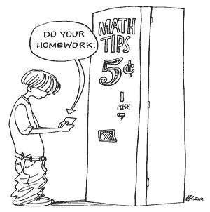
- SMALL…
  - Photo for bulletin board(labeled moment you were happy &/or proud)
  - Kleen-X &/or paper towels
  - Gallon jug of distilled water
  - Random in-class research, competitions and problem solving opportunities
- MEDIUM…
  - Science podcast, article or science book chapter summary and follow-up discussion w/Mrs. Trine. I have several suggestions for topics if this sounds interesting or you may choose your own and run it by me. Podcasts, articles and chapters must be from legitimate science sources and approved by me to be worth extra credit.
- LARGE…
  - Off campus science activities as posted or announced by Mrs. Trine
  - Science Fair

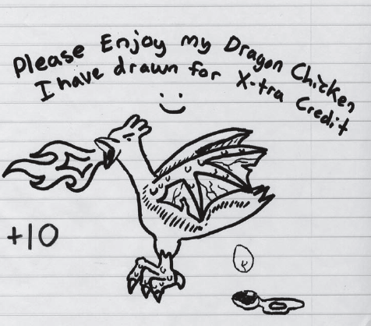
Extra credit will not appear as a separate category in Aspen, but will be consulted after all other assignments and assessments have been graded and entered into Aspen. If the extra credit earned is enough to change the final grade in the course, I will adjust the final course grade at that point.

EXTRA CREDIT OPPORTUNITIES!
- SMALL…
  - Photo for bulletin board(labeled moment you were happy &/or proud)
  - Kleen-X &/or paper towels
  - Gallon jug of distilled water
  - Random in-class research, competitions and problem solving opportunities
- MEDIUM…
  - Science podcast, article or science book chapter summary and follow-up discussion w/Mrs. Trine. I have several suggestions for topics if this sounds interesting or you may choose your own and run it by me. Podcasts, articles and chapters must be from legitimate science sources and approved by me to be worth extra credit.
- LARGE…
  - Off campus science activities as posted or announced by Mrs. Trine
  - Science Fair
Extra credit will not appear as a separate category in Aspen, but will be consulted after all other assignments and assessments have been graded and entered into Aspen. If the extra credit earned is enough to change the final grade in the course, I will adjust the final course grade at that point.

